**CINEMA TICKETING AND RESERVATION SYSTEM**

**Functional**

**1.0 Cinema Ticketing and Reservation System**

**1.1 Admin/Staff Login**

1.1 Login (Existing Account)

1.2 Create New Account

**1.2 Dashboard**

2.1 Next Movies

2.2 Now Showing (Movies)

**1.3 Manage Reservation**

3.1 List of Reservation

3.2 Add Reservation

3.3 Manage Reservation Details

3.4 Save

3.5 Print

3.6 Cancel

3.7 Manage Customer Details

3.8 Save

3.9 Cancel

4.0 Manage Actions

**1.4 Manage Movies**

4.1 List of movies

4.2 Add Movies

4.3 Manage Actions

**1.5 Manage Cinema Halls**

5.1 Add cinema

5.2 Manage Actions

**1.6 Users**

6.1 Add user

6.2 Choose Actions

6.3 Save

6.4 Cancel

6.5 Manage Actions

**1.7 Reports**

7.1 Sales Report

7.2 Login Report

7.3 Movies Report

**1.8 Logout**

8.1 Logout Account

**Decomposition Diagram**

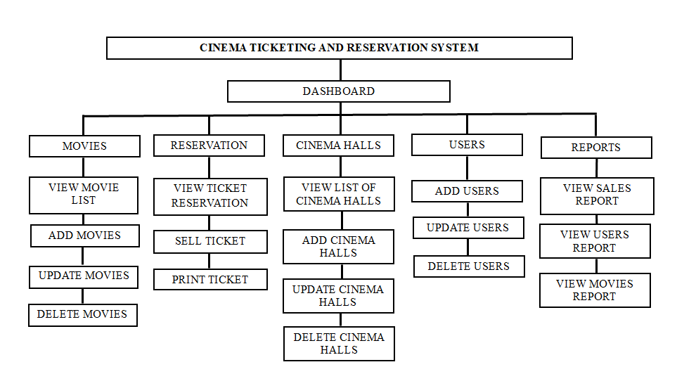

**Flowchart**



